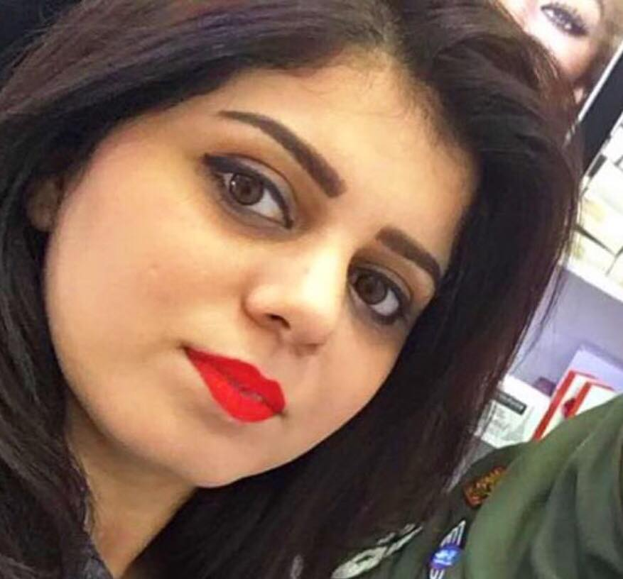

Sama Qusay Abdulghafoor
samaqusay1@gmail.com
07712813080
Yarmouk, Baghdad, Iraq

------------------------------------------------------------------------------------------------------------------

SUMMARY OF QUALIFICATIONS

- Sound knowledge of life-science curriculum frameworks.
- Through knowledge in teaching innovative and inquiry-based approaches in science.
- Professional Experience in Microsoft office (Word, Excel, Access, PowerPoint, Outlook)
- Remarkable ability to be flexible in assignment and tasks.
- Strong interpersonal and organizational skills.
- Capacity of analysis, synthesis and reporting.
- Excellent motivational and instructional skills.

------------------------------------------------------------------------------------------------------------------

Work History:

1). From Oct. 2018 to Mar.2019

- Worked for: Noor Al-A'sema Scientific Bureau
- Work Location: Baghdad -Alyarmouk
Job Title: Sales Team Leader

1). From Jan. 2016 to Oct.2018

- Worked for: skinconcept medical company
- Work Location: Baghdad Alkarkh and Alrasafah
- Job Title: Medical representative.

------------------------------------------------------------------------------------------------------------------

Educational Qualifications:

B.Sc. in Biology, Baghdad University College.

------------------------------------------------------------------------------------------------------------------

Personal interest And Hobbies:

- Reading
- Music
- Internet Browsing
- Cooking

------------------------------------------------------------------------------------------------------------------
Contacts information:

Mobile No. : 07712813080

E-Mail: samaqusay1@gmail.com

------------------------------------------------------------------------------------------------------------------

